**Analysis of the Sex Dataset**

There are 9 records of the number of months prior to becoming pregnant was collected. One of the exact time in records is unknown because the experiment terminated. We set the unknown value as censored value and others are non-censored value.

We estimated the probability of a pregnancy in a given month (p). From the plot 1, the probability of becoming pregnant in a month with unprotected intercourse is about 0.205 (SE=0.065).

Then, from the plot 1 again, the asymptotic CI and the profile CI are **NOT** equivalent.

In the nlm method, the lower and upper limit have **equal distance** from the MLE estimator because the **asymptotic CI** is calculated based on the assumption of asymptotic normality for the MLE estimator.

However, in mle2 method, the two limits have the **same height** below the MLE estimator because the **profile CI** is calculated based on profile likelihood. We directly use the log-likelihood function. A likelihood ratio test computes the test-statistic and ittwice the difference between the log-likelihood at the maximum and at a specified point follows χ^2 distribution with 1 df. The profile CI is better when we have small sample.

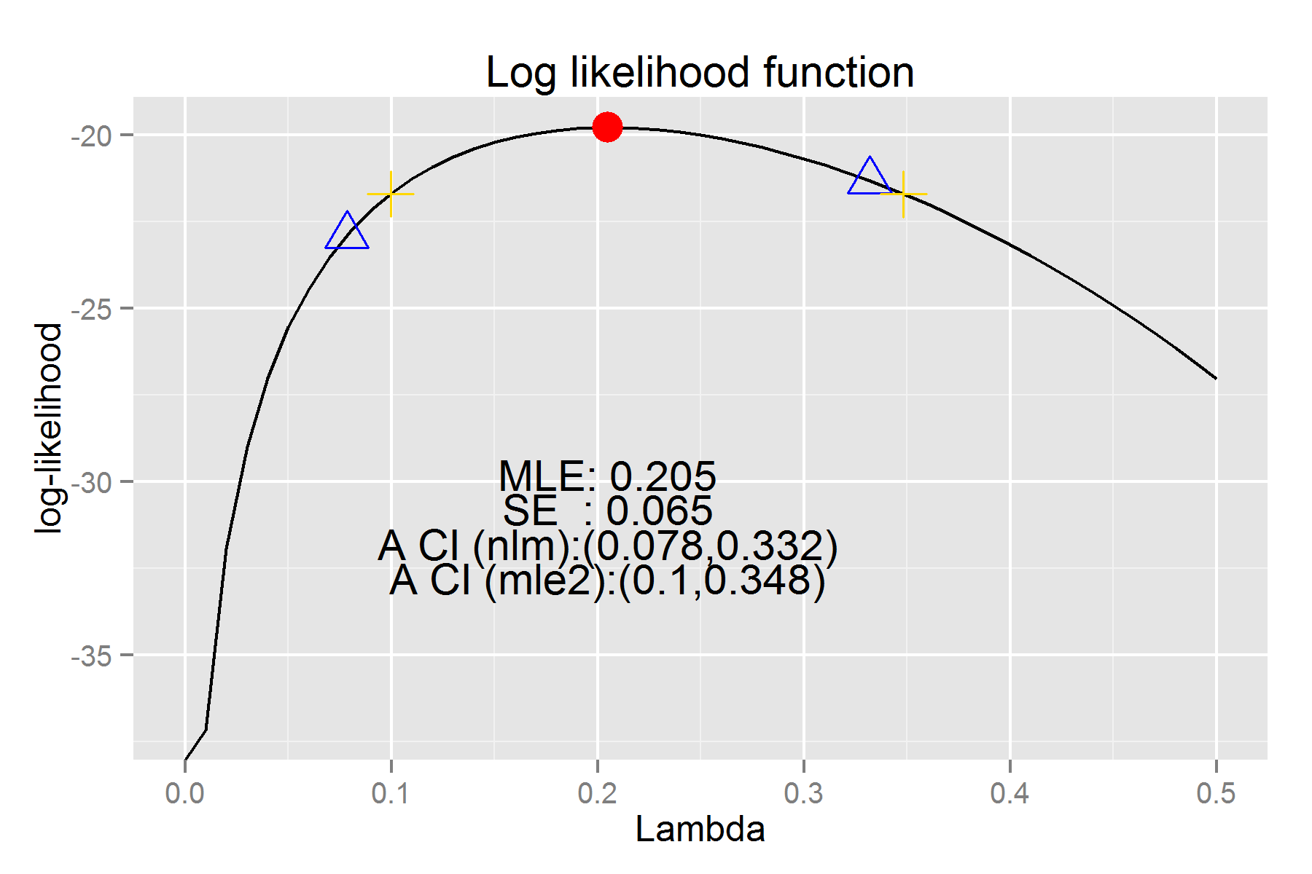

*Plot 1: The log-likelihood function against lambda with the MLE (red point) and*

*asymptotic CI (blue triangle marked) & profile CI (gold cross marked)*